THIS FORM IS INTENDED TO HELP YOU EVALUATE PATIENTS WITH PELVIC PAIN.

THE FORM WILL WALK YOU THROUGH THE PHYSICAL EXAM AND PROVIDE GUIDANCE ON FORMULATING AN ASSESSMENT AND PLAN.

THIS FORM CAN BE USED FOR DOCUMENTATION, HOWEVER, NOTE THAT THE PATIENT HISTORY IS COLLECTED THROUGH THE PATIENT INTAKE SURVEY.IF YOU CHOOSE TO USE THIS FORM FOR DOCUMENTAITON PURPOSES, YOU WILL NEED TO ADD THE PATIENT INFORMATION FROM THE HISTORY FORM.

ALTERNATIVELY, YOU CAN USE THIS FORM FOR PLANNING AND THINKING PURPOSES AND USE THE ELECTRONIC HEALTH RECORD TEMPLATE FOR DOCUMENTATION.

PATIENT IDENTIFIERS
Note: If you are collecting HIPAA / HPI you must ensure these forms are secured
Physical Examination Date:Click or tap here to enter text.
Last Name: Click or tap here to enter text.
First Name: Click or tap here to enter text.
Last 4 SSN:Click or tap here to enter text.
EXAMINATION
General Appearance: (Check all that apply)
☐Well-appearing ☐Ill-appearing ☐Tearful ☐Depressed
☐Normal weight ☐Underweight ☐Overweight
☐Abnormal Gait ☐Other:Click or tap here to enter text.

Head, ears, nose and throat: ☐WNL ☐Other: Click or tap here to enter text.
Lungs: ☐Normal ☐Other: Click or tap here to enter text.
Heart: ☐Normal ☐Other: Click or tap here to enter text.
Abdomen:
☐Normal ☐Non-tender ☐Tender ☐Inguinal tenderness
☐Mass ☐Inguinal bulge ☐Suprapubic tenderness ☐Guarding ☐Rebound ☐Distention
☐Sensory abnormality (allodynia or hyperalgesia) Location:Click or tap here to enter text.
☐Positive Carnet’s sign
☐Trigger Points: Number:Click or tap here to enter text. Location:Click or tap here to enter text.
☐Surgical scars: Number: Click or tap here to enter text. Location:Click or tap here to enter text.
☐Surgical scar pain present (describe location and severity):Click or tap here to enter text.
☐Other, including pain severity and radiation patterns, describe all abnormalities here:Click or tap here to enter text.
Musculoskeletal (External):
Lumbar range of motion | ☐Normal | ☐Painful with flexion  ☐Painful with extension  ☐Painful with rotation  ☐Painful with side bending
Sacroiliac joints | ☐Normal | ☐Painful right  ☐Painful left
Pubic symphysis | ☐Normal | ☐Painful with palpation
Active straight leg raise test | ☐Normal | ☐Painful right  ☐Painful left
Hip flexion | ☐Normal | ☐Painful right  ☐Painful left
Hip Ab/Adduction | ☐Normal | ☐Painful right  ☐Painful left
Posture | ☐Normal | ☐Altered
Gait | ☐Normal | ☐Knee pain  ☐Leg discrepancy  ☐Other:Click or tap here to enter text.
Other abnormalities noted:Click or tap here to enter text.

Neurologic (External):
Distribution |  | Right | Left
Iliohypogastric | ☐Normal | ☐Allodynia  ☐Hyperalgesia | ☐Allodynia  ☐Hyperalgesia
Ilioinguinal | ☐Normal | ☐Allodynia  ☐Hyperalgesia | ☐Allodynia  ☐Hyperalgesia
Genitofemoral | ☐Normal | ☐Allodynia  ☐Hyperalgesia | ☐Allodynia  ☐Hyperalgesia
Posterior femoral cutaneous | ☐Normal | ☐Allodynia  ☐Hyperalgesia | ☐Allodynia  ☐Hyperalgesia
Lateral femoral cutaneous | ☐Normal | ☐Allodynia  ☐Hyperalgesia | ☐Allodynia  ☐Hyperalgesia
Pudendal | ☐Normal | ☐Allodynia  ☐Hyperalgesia | ☐Allodynia  ☐Hyperalgesia
Obturator | ☐Normal | ☐Allodynia  ☐Hyperalgesia | ☐Allodynia  ☐Hyperalgesia
Anal wink reflex | ☐Normal | ☐Absent
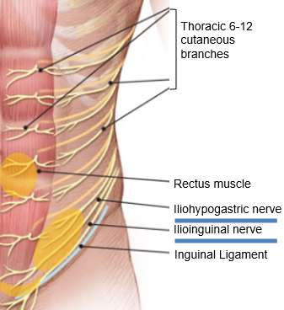
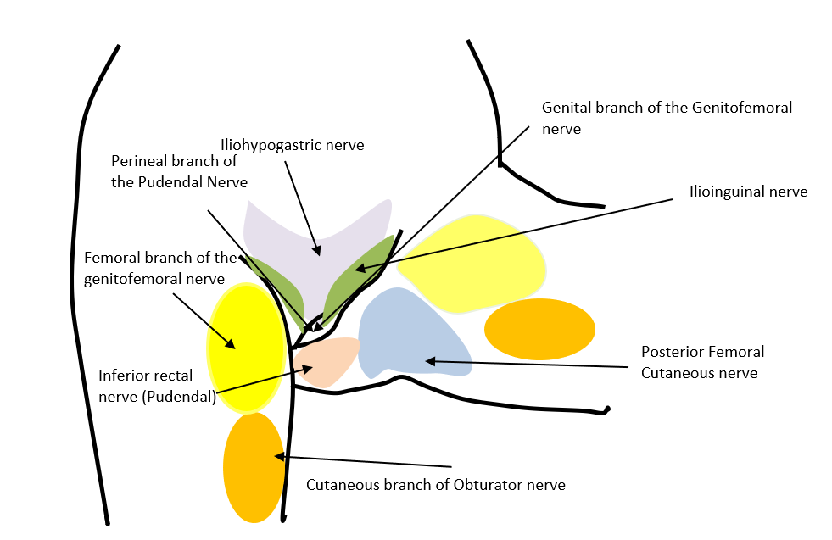

Body Pain Map:
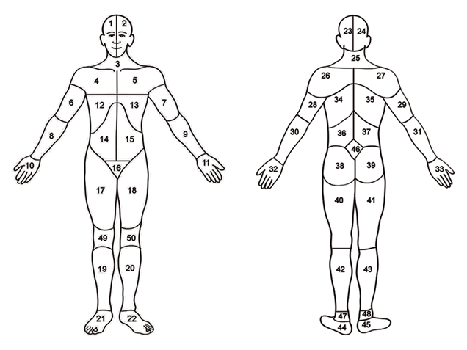
List the numbers of all the sites where the patient reports pain:Click or tap here to enter text.

Add comments, including pain severity and radiation patterns:Click or tap here to enter text.
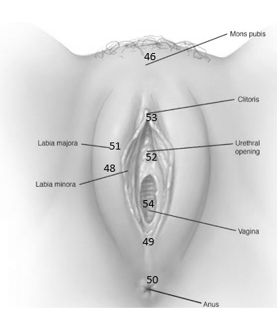
External Visual Examination of Genitalia:☐Normal ☐Atrophy
☐Discharge ☐Bleeding
☐Masses, Lesions; Describe:Click or tap here to enter text.
12 o’clock
☐Hyperkeratosis; Location: Click or tap here to enter text.
☐Tenderness; Location:Click or tap here to enter text.
☐Vestibular erythema; Location:Click or tap here to enter text.
Posterior fourchette (49)
☐Allodynia; Location:Click or tap here to enter text.
☐Hyperalgesia; Location:Click or tap here to enter text.
6 o’clock
Note, describe pain location, radiation and abnormalities in further detail here using location numbers:Click or tap here to enter text.
Single Digit Pelvic Floor Muscle Examination (Note- assess tenderness, tone, strength and voluntary control):
Muscle | Tenderness  (0-4) | Baseline Tone (0-4) | Strength (0-4) | Voluntary control
Right obturator internus | ☐0 ☐1 ☐ 2 ☐3 ☐4 | ☐0 ☐1 ☐ 2 ☐3 ☐4 | ☐0 ☐1 ☐ 2 ☐3 ☐4 | Present☐  Absent☐
Left obturator internus | ☐0 ☐1 ☐ 2 ☐3 ☐4 | ☐0 ☐1 ☐ 2 ☐3 ☐4 | ☐0 ☐1 ☐ 2 ☐3 ☐4 | Present☐  Absent☐
Right Pubococcygeus | ☐0 ☐1 ☐ 2 ☐3 ☐4 | ☐0 ☐1 ☐ 2 ☐3 ☐4 | ☐0 ☐1 ☐ 2 ☐3 ☐4 | Present☐  Absent☐
Left Pubococcygeus | ☐0 ☐1 ☐ 2 ☐3 ☐4 | ☐0 ☐1 ☐ 2 ☐3 ☐4 | ☐0 ☐1 ☐ 2 ☐3 ☐4 | Present☐  Absent☐
Right Coccygeus | ☐0 ☐1 ☐ 2 ☐3 ☐4 | ☐0 ☐1 ☐ 2 ☐3 ☐4 | ☐0 ☐1 ☐ 2 ☐3 ☐4 | Present☐  Absent☐
Left Coccygeus | ☐0 ☐1 ☐ 2 ☐3 ☐4 | ☐0 ☐1 ☐ 2 ☐3 ☐4 | ☐0 ☐1 ☐ 2 ☐3 ☐4 | Present☐  Absent☐
Right Iliococcygeus | ☐0 ☐1 ☐ 2 ☐3 ☐4 | ☐0 ☐1 ☐ 2 ☐3 ☐4 | ☐0 ☐1 ☐ 2 ☐3 ☐4 | Present☐  Absent☐
Left Iliococcygeus | ☐0 ☐1 ☐ 2 ☐3 ☐4 | ☐0 ☐1 ☐ 2 ☐3 ☐4 | ☐0 ☐1 ☐ 2 ☐3 ☐4 | Present☐  Absent☐
Right bulbocavernosus | ☐0 ☐1 ☐ 2 ☐3 ☐4 | ☐0 ☐1 ☐ 2 ☐3 ☐4 | ☐0 ☐1 ☐ 2 ☐3 ☐4 | Present☐  Absent☐
Left bulbocavernosus | ☐0 ☐1 ☐ 2 ☐3 ☐4 | ☐0 ☐1 ☐ 2 ☐3 ☐4 | ☐0 ☐1 ☐ 2 ☐3 ☐4 | Present☐  Absent☐
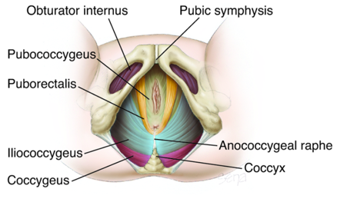

Click or tap here to enter text.
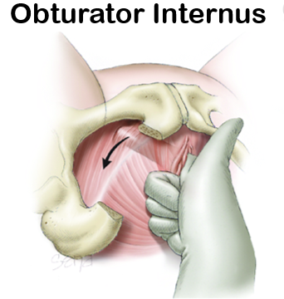
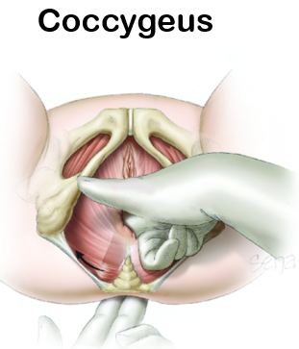
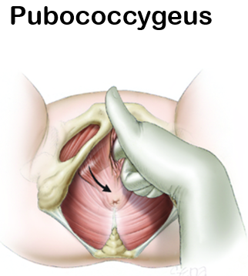
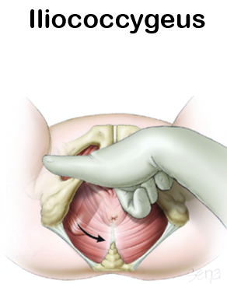

Coccyx: ☐Tender ☐Non-tender

Tenderness with compression of ischial spine: ☐Non-tender right ☐Tender right
☐Non-tender left ☐Tender left
If tender, is the pain in the distribution of the pudendal nerve when the ischial spine is compressed (Valleix sign): ☐Yes ☐No
Internal Pelvic Examination:
Cervix | ☐Normal | ☐Tender; Describe:Click or tap here to enter text.  ☐Mass; Describe:Click or tap here to enter text.
Urethra | ☐Normal | ☐Tender; Describe:Click or tap here to enter text.  ☐Mass; Describe:Click or tap here to enter text.
Bladder | ☐Normal | ☐Tender; Describe:Click or tap here to enter text.  ☐Mass; Describe:Click or tap here to enter text.
Rectovaginal vault | ☐Normal | ☐Tender; Describe:Click or tap here to enter text.  ☐Mass; Describe:Click or tap here to enter text.
Vaginal apex (if cervix is absent) | ☐Normal | ☐Tender; Describe:Click or tap here to enter text.  ☐Mass; Describe:Click or tap here to enter text.

Bimanual Examination:

Uterus: ☐Normal ☐Absent
☐Tender ☐Anterior location ☐Posterior location
☐Enlarged size, enter size: Click or tap here to enter text.
☐Irregular shape ☐Fixed ☐Firm
☐Prolapse, describe stage: Click or tap here to enter text.

Adnexa: ☐Normal ☐Absent right ☐Absent left
☐Tender right ☐Tender left
☐Fixed right ☐Fixed left
☐Enlarged right: Click or tap here to enter text.
☐Enlarged left: Click or tap here to enter text.

Rectal: ☐Normal ☐Nodules ☐Hemoccult positive
☐Tenderness ☐Hemorrhoids ☐Other:Click or tap here to enter text.

Additional Comments: Click or tap here to enter text.

ASSESSMENT AND PLAN
Suspected Initial Diagnosis (Check all that apply)
Uro-Gynecologic
☐Endometriosis  ☐Adenomyosis | ☐Dysmenorrhea | ☐Fibroids
☐Ovarian cyst(s) | ☐Ovarian remnant | ☐Pelvic congestion syndrome
☐Dyspareunia | ☐Premenstrual Syndrome | ☐Genitourinary syndrome of menopause
☐Pelvic organ prolapse  ☐Cystocele  ☐Rectocele  ☐Cervical prolapse  ☐Uterine prolapse | ☐Vulvodynia  ☐Generalized  ☐Localized  ☐Spontaneous  ☐Provoked | ☐Vulvar pain with known etiology, list:
☐IC/BPS | ☐Urinary urgency | ☐Urinary frequency or Overactive Bladder
☐Urinary incontinence | ☐Urinary tract infection | ☐Urethral mass
☐Prostatitis (bacterial or non-bacterial) | ☐Urethritis | ☐Prostate mass or BPH
☐Sexually transmitted infection | ☐Orchitis, Scrotal pain | ☐Urethral or bladder stones
Gastroenterologic
☐IBS-Diarrhea | ☐IBS-Constipation | ☐IBS-Mixed
☐Diarrhea | ☐Constipation | ☐Fecal incontinence
☐Dyschezia | ☐Inflammatory bowel disease | ☐Diverticulosis/itis
Neurologic
☐Neuralgia  List site: | ☐Pudendal neuropathy
Non-Genital Pain Syndromes
☐Chronic fatigue | ☐Fibromyalgia | ☐Migraines / Headaches
☐TMD | ☐Chronic low back pain
Musculoskeletal | ☐None
☐Pelvic floor muscle dysfunction | ☐Myalgia
Psychosocial
☐PTSD | ☐Sexual trauma / abuse | ☐Physical abuse
☐Depression | ☐Anxiety | ☐Suicide ideation or intent
☐Sleep disorder | ☐Catastrophizing | ☐Rumination
☐Substance abuse | ☐Opioid use ☐Opioid abuse ☐Opioid side effects
Pain Descriptors
☐Pelvic Pain | ☐Chronic pelvic pain | ☐Chronic pain syndrome
Other Diagnoses not listed above:

Recommended treatments
☐Acupuncture ☐Massage ☐Nutrition/Diet ☐Physical Therapy ☐Biofeedback
☐Trigger Point Injections ☐TENS Unit ☐Botox Injections ☐Nerve Blocks
☐Epidural ☐Sex Therapy ☐Joint Injections ☐Neurostimulation
☐Mental Health ☐Bladder instillations ☐Aqua Therapy ☐Radio Frequency Ablation
☐Cognitive Behavioral Therapy ☐Percutaneous Tibial Nerve Stimulation ☐NONE
☐Hormonal treatment-- if yes, what type of hormonal treatment? (Check all that apply)
☐Pills ☐Patch ☐Ring ☐ Injections ☐Estrogen ☐Progesterone
Other treatments:Click or tap here to enter text.

Recommended Pharmacotherapy
Medication | Dose | Instructions for use
☐NONE
Recommended Surgery
Surgery Name | Primary Indication for surgery
☐NONE
Referrals
☐Gastroenterology ☐Urology ☐Urogynecology ☐Reproductive Endocrinology and Infertility
☐Endocrinology ☐Medicine ☐Primary care ☐Pain management ☐NONE
☐Other:Click or tap here to enter text.

Additional psychosocial or medical factors contributing to pain:
Click or tap here to enter text.
Additional medical co-morbidities that impact pain not listed above in the ‘diagnosis’ section: Click or tap here to enter text.

Shared Decision Making and Goal Setting
Patient goals (should be focused and attainable)
Short-term:Click or tap here to enter text.
Long-term:Click or tap here to enter text.
Potential obstacles to attaining goals identified by patient and the provider:Click or tap here to enter text.
Shared decision making
Patient selected therapies: Click or tap here to enter text.
Treatments recommended by the provider but not accepted by the patient: Click or tap here to enter text.

